**Emarsys - Quick Functionality Overview**

**Table of Contents**

Functional overview 3

Business manager 4

Newsletter subscription box – global footer/checkout process/ My account page 4

Transactional emails – order confirmation 5

Transactional emails – shipping confirmation 5

Transactional emails – order cancelled 5

Initial Database Load – configuration screen 5

Send Order Confirmation Email – send email 5

External events page 6

Storefront functionality 6

Newsletter subscription box – global footer 6

Newsletter subscription during checkout process 7

Newsletter subscription/unsubscription – My Account 8

B2C Commerce landing pages 9

Emarsys Predict JavaScript Recommendations 10

Job 11

Emarsys-Setup 11

Emarsys-ExportOrders 12

Emarsys-Init-Database 12

Emarsys-ExportCatalog 12

Emarsys - OrderStatusСhangeNotification 12

## Functional overview

The Emarsys integration cartridges will allow the merchant to:

* Use the Emarsys Business Manager module extension to make the necessary configurations for the following:
  + Newsletter subscriptions methods (global footer subscription, checkout process subscription, and my account subscription):
    - Define the opt-in strategy for each newsletter subscription method (please see below details regarding the opt-in strategies)
    - Configure external events to be triggered once the end user has subscribed
  + Transactional emails (order and shipping confirmation emails)
    - Define and map the fields that will be added to the transactional emails
    - Configure the external event that will trigger the transactional email
  + Catalog configuration (Product data feed)
    - Define and map the fields that will be added to the product export feed
    - Choose the type of catalog product export
      * Export only main product
      * Export product variations
  + SmartInsight configuration (Order export feed)
    - Define and map the fields that will be added to the order export feed
  + Initial database load
    - Define the mapping between B2C Commerce and Emarsys fields – this mapping will be used to create the auto-import profile (calling an Emarsys endpoint) and to send data directly on Emarsys using the API.
* Allow end users to subscribe to newsletters from the website storefront using the subscription methods:
  + Global footer newsletter subscription
  + Newsletter subscription during the checkout process
  + Newsletter subscription from *My account* section for registered users
* Allow registered end users to unsubscribe from newsletters

As stated above, the merchant has the option to set the desired opt-in strategy for each one of the three storefront subscription methods. The available values for the opt-in strategy are the following:

* + Single opt-in – the customer records get the system field opt-in in Emarsys Suite set to true immediately.
  + Double opt-in – the customer (end user) needs to click a link in a confirmation email in order to get the system field opt-in in Emarsys Suite set to true.

External events – an external event is an Emarsys instance. Every external event has ID that can be used to run some programs or send emails using Emarsys API. External events used not only to subscribe customers for newsletters. There are also some other cases where external events are triggered:

* + On **Contact Us** page after form is submitted
  + In **Emarsys-OrderStatusСhangeNotification** job to notify Emarsys about shipped and canceled orders
  + On **Login** page when customer sends email to reset password
  + On **Login** page when new customer account is created (registration form submitted)

JavaScript tracking code was embedded in Phase2 of the Emarsys code. The analysis generates product recommendations and maps personal interests of users based on browsing information collected from website (product views, searches, conversions). The information is collected by a set of JavaScript snippets that were embedded into website page templates.

These JavaScript commands are pushed to Emarsys Predict:

* cart: on the page where the cart is shown
* category: on pages which lists products in a category
* purchase: on the order confirmation page
* setCustomerId: on every page as soon as the customerid is known
* setEmail: on every page as soon as the email address is known
* view: on every product detail page
* searchTerm: on the search results page

## Business manager

A new Business Manager extension has been created in order to allow the merchant to configure the behavior for newsletter subscriptions and to define the B2C Commerce fields that will be added to the transactional emails (order and shipping confirmation emails) that will be send through the Emarsys platform. The extension will also allow the merchant to map B2C Commerce with Emarsys fields for the initial DB load feature.

### Newsletter subscription box – global footer/checkout process/ My account page

1. The page opens with the **Global/checkout/account footer** tab selected by default.
2. The merchant needs to select the **Opt-in** strategy. There are two options available:

* *Single Opt-In* (recipient gets opt-in system field set to true immediately in the Emarsys Suite). Optionally the merchant can select an external event that gets fired after the user record was transmitted to Emarsys.
* *Double Opt-In* (recipient needs to click a confirmation link in an email in order to get the system field opt-in in Emarsys Suite set to true). If double opt-in is selected, then the merchant must select the external event that should be triggered in Emarsys Suite to send out the confirmation email. Optionally the merchant can set a second event that will be triggered as soon an end user clicks the confirmation link (e.g. to send a welcome email).

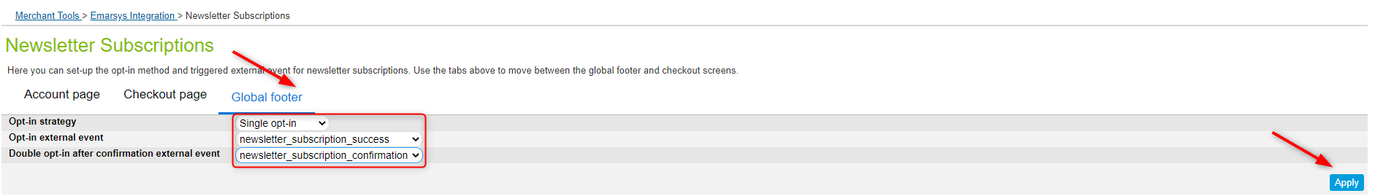

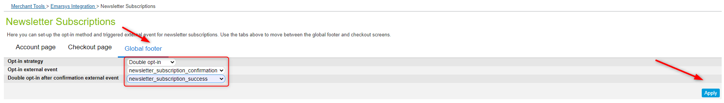

### Transactional emails – order confirmation

As soon as an end user finishes a transaction, the order data should be transmitted to Emarsys Suite and the corresponding external event must be triggered. The external event will trigger an order confirmation email. B2C Commerce will check in the Emarsys Suite if the user record already exists and based on the result it will update the record or create a new one. Also, the merchant has the option to choose what fields will be included in the order confirmation email.

### Transactional emails – shipping confirmation

As soon as a shipment was finished an email should be sent to the end user and the corresponding external event must be triggered. The external event will trigger a shipping confirmation email.

### Transactional emails – order cancelled

As soon as a shipment was finished an email should be sent to the end user and the corresponding external event must be triggered. The external event will trigger an order cancelled email.

### Initial Database Load – configuration screen

The initial database load feature will upload the existing B2C Commerce customers to the Emarsys Suite. Please find below the steps required to accomplish this :

* Create the mapping between B2C Commerce and Emarsys fields using the initial database load configuration screen. The mapping will be used to generate an auto-import profile on Emarsys side and to send data directly on Emarsys using the API.

In order to generate the mapping, a new configuration screen has been created.

### Send Order Confirmation Email – send email

You can manually send order confirmation email to the customer at the order number via Emarsys service.

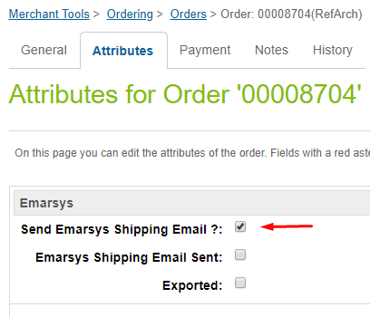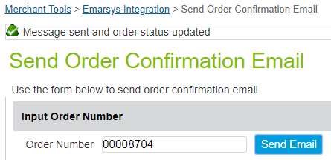

After sending the message, the order changes the status of (sendEmarsysShippingEmail).

### External events page

After successful execution of Emarsys-Setup job all initial events configuration is already set. External events page is developed to change events configuration easily. In order to get there, you should:

All external events are separated by its type into two tables: **Newsletter Subscription Events** and **Other Events**. Events mapping are taken from appropriate fields of **EmarsysExternalEvents** custom object.

Each table has **Add event** button over the top right corner. You should use this button to map new SFCC events. Depending on the type of the event, new SFCC event should be listed in one of **EmarsysExternalEvents** source fields (**newsletterSubscriptionSource** or **otherSource**) but should not be presented on the page (should not yet be mapped).

If appropriate Emarsys event is chosen for mapping, this Event will be created using Emarsys API. If there are any issues during request, error notification will be shown at the top of the events page.

## Storefront functionality

By installing the Emarsys cartridge, the retailers will provide their end user with the option of subscribing to newsletters from the website storefront. There are 3 ways for an end user to accomplish this:

* + using the newsletter subscription box displayed on the global footer
  + during the checkout process, by selecting the *Please add me to the B2C Commerce email list. B2C Commerce does not share or sell personal info* checkbox on the billing page
  + from B2C Commerce *My Account* page

All these options are detailed in the lines below.

### Newsletter subscription box – global footer

The end user can subscribe for newsletters from footer on every page of the storefront. There are 2 ways to do that:

* + Subscribe directly by typing the email address in the subscription box and clicking the subscribe button.

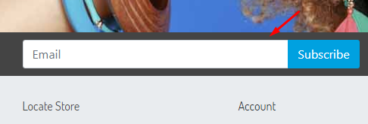

* + Clicking on subscribe button without entering any data into field. This will redirect user to **Sign up form.** Completing all the necessary fields and clicking on the **Sign me up for email** button will subscribe the user. The data is sent to Emarsys.

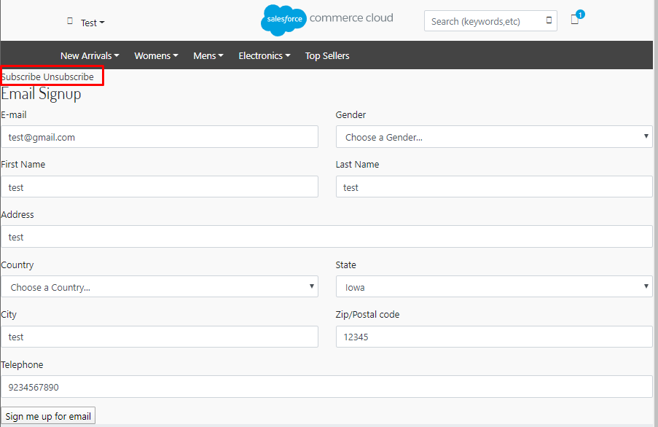

### Newsletter subscription during checkout process

The end user also has the option to subscribe for a newsletter during the checkout process, as described below but you need to add this option to the default subscription is false.

1. As a guest/registered user **add a product to cart.**
2. Proceed to checkout
3. On the billing step **type in your email address** in the e-mail field.
4. Select *Please add me to the B2C Commerce email list. B2C Commerce does not share or sell personal info* and *I have read the Privacy Policy and I agree* checkboxes.

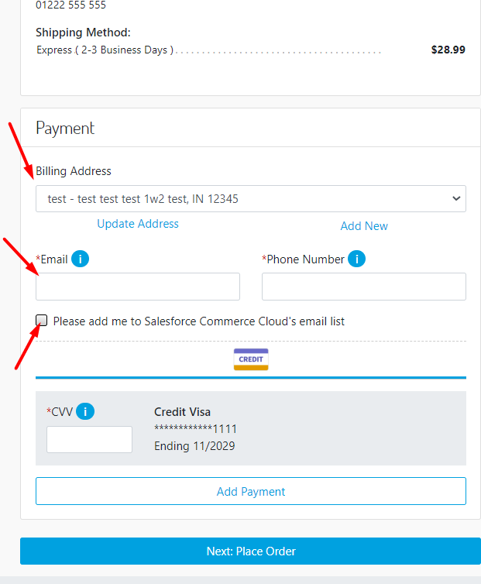

1. Complete all the mandatory fields and **proceed to next step**, so thatthe end user data to be send to Emarsys Suite.

### Newsletter subscription/unsubscription – My Account

Registered user has the option to subscribe/unsubscribe from newsletter from the Profile ***but this functionality needs to be added on Storefront.***

1. Open the storefront and **log in.**
2. In the left navigation bar click on the **Email Settings** link.
3. Clicking the **Subscribe** button will open an email sign up form. Complete the fields and hit the **Sign me up for email** button to subscribe for newsletters.

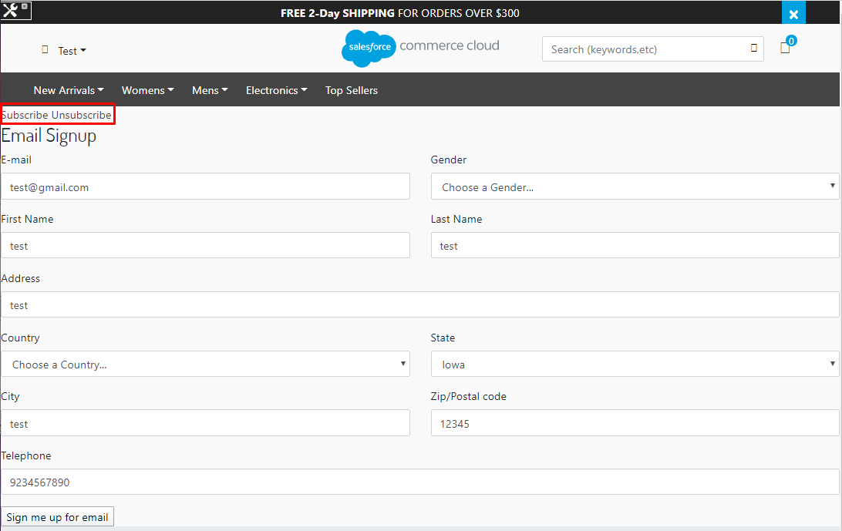

1. Clicking the **Unsubscribe** button will unsubscribe the end user from newsletters.

### B2C Commerce landing pages

Depending on which opt-in strategy has been configured for the subscriptions methods and depending on the unsubscription strategy (direct/indirect), the end user can be redirected to several landing pages, as following:

* + Thank you page – Single Opt-in strategy

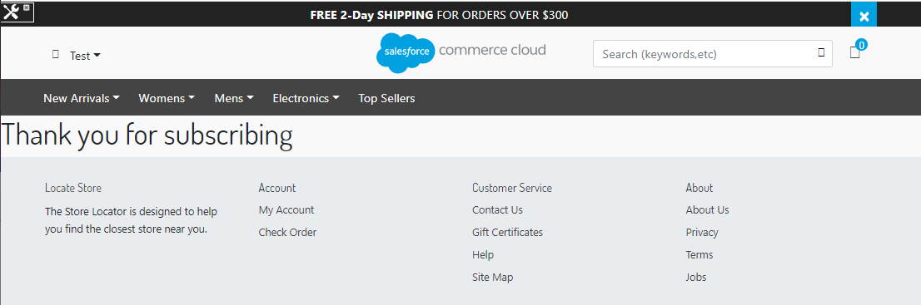

* + Data submitted page – Double Opt-in strategy

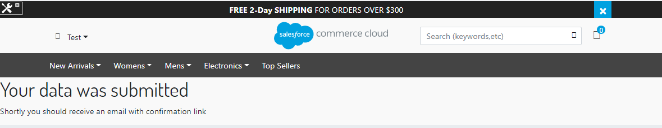

* + Thank you page – Double Opt-in strategy

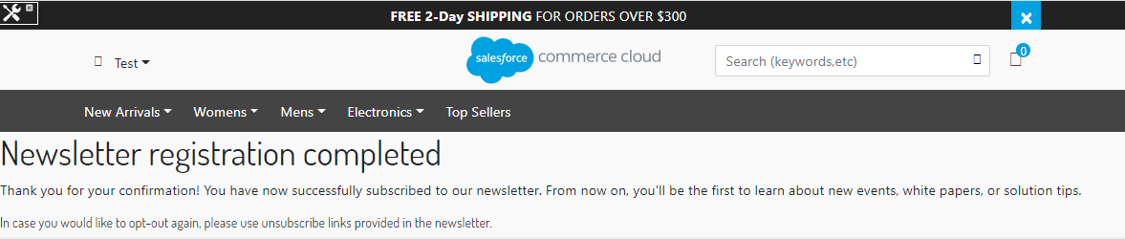

* + Thank you page – Unsubscribe

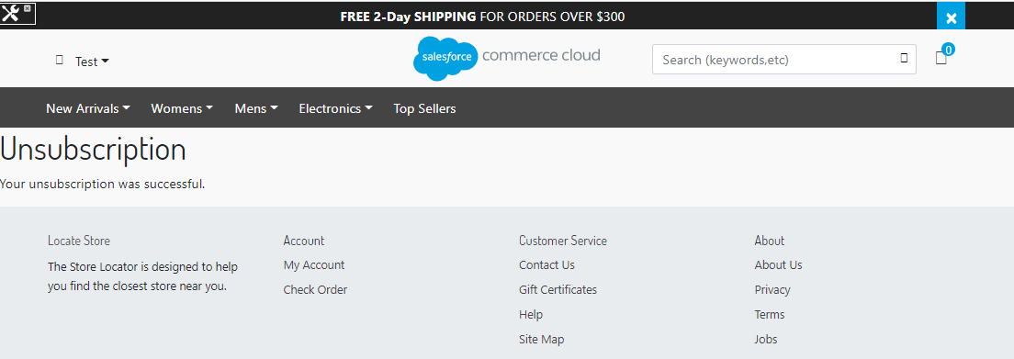

### Emarsys Predict JavaScript Recommendations

Emarsys Predict is being used to recommend products based on a self-learning algorithm. Recommended products can be rendered within shop pages and within emails. Emarsys has its own system ScarabResearch that renders the recommendations.

The user browsing information is pushed into Emarsys on the following pages:

* Cart page: list of items in the visitor's shopping cart
* Category page: category currently browsed by visitor
* Order Confirmation Page: list of items purchased by the customer
* Search Page: Push search term entered by visitor
* Product Page: Push the unique ID of the product being browsed

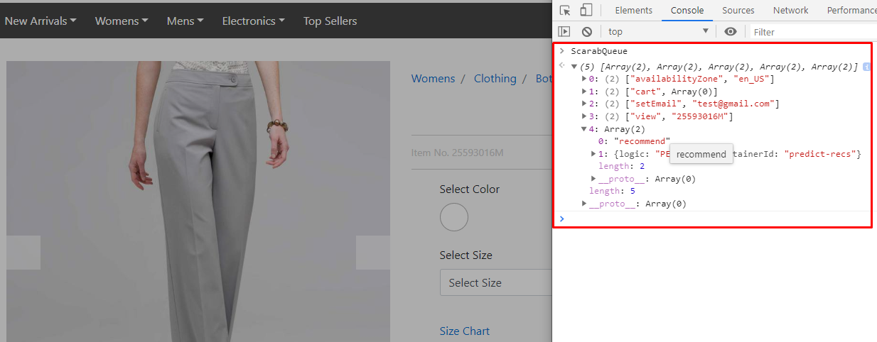

While browsing the site the user should be able to see the recommendations at the following pages:

* Product detail page
* Home page
* Cart page
* Search results page
* Category page
* Order confirmation page

Recommendations are displayed based on previous user actions from the recommendation catalog exported into Emarsys.

**Use Case:**

1. User enters to the site
2. Customer visits product detail page of some product
3. Customer adds product to the basket
4. Customer goes to the cart page
5. The list of recommendations recommended by Emarsys Scarabresearch in displayed

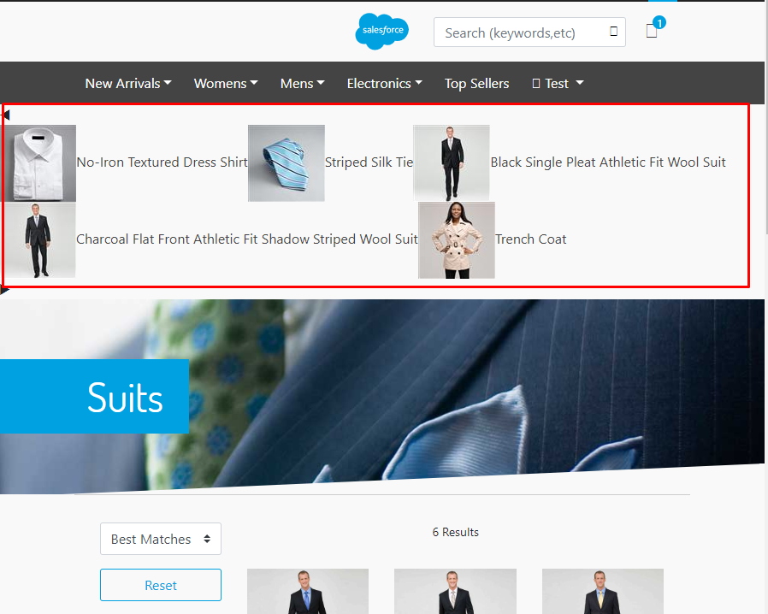

## Job

### Emarsys-Setup

Once the cartridges are installed and the credentials have been configured inside Business Manager, a job schedule needs to be run in order to get from the Emarsys platform all the data that is necessary for the integration to work:

* Emarsys profile fields (profile fields are stored in a custom object on Salesforce Commerce Cloud side: *EmarsysProfileFields*)
* External events configuration (whitelisted SFCC side events and their mapping with Emarsys side events: *EmarsysExternalEvents*)
* The source id defined on Emarsys (will be saved on Salesforce Commerce Cloud side in a custom preference attribute: *Merchant Tools > Site Preferences > Custom Site Preferences > Emarsys > Emarsys Source ID*)
* All available values for Emarsys single choice fields (will be saved on Salesforce Commerce Cloud side in a custom preference attribute: *Merchant Tools > Site Preferences > Custom Site Preferences > Emarsys DB Init Configuration > Emarsys Single Choice Value Mapping*)

All this data will be automatically stored on Salesforce Commerce Cloud when the job is successfully executed.

### Emarsys-ExportOrders

**EmarsysExportOrders** will export order data into csv file through new Job Schedule. Every field in the CSV file will be mapped to a corresponding field defined in the Emarsys documentation.

### Emarsys-Init-Database

This job generates a user profile and sends profile data directly to Emarsys.

### Emarsys-ExportCatalog

A new job schedule **Emarsys-ExportCatalog** will export catalog data into csv. Every field in the CSV file will be mapped to a corresponding field defined in the Emarsys documentation.

### Emarsys - OrderStatusСhangeNotification

This job initialized send email about confirmation or cancellation order through campaign on Emarsys